A Systematic Review of AI-Enabled Wearable and IoMT-Based Health Monitoring Systems: Sensing, Edge Intelligence, Federated Learning, and Health Interventions
Aakash Dinesh Yadav*
Dalhousie University, Halifax, Nova Scotia, Canada
Second Author's Name
Second author's affiliation, possibly the same institution, xxxx@gmail.com
This study presents a systematic literature review (SLR) examining the intersection of wearable sensing technologies, mobile health systems, and artificial intelligence for lifestyle behaviour monitoring and health intervention. A total of 137 studies published between 2015 and 2026 were identified and analyzed from five major academic databases. The review provides a structured synthesis of how sensing modalities, data processing techniques, and intelligent system architectures are used to infer lifestyle behaviours and support health-related decision-making. The findings indicate a strong dominance of wearable-based sensing and passive data collection approaches, with physiological and activity-related behaviours being the most frequently studied. Deep learning techniques emerge as the predominant analytical method, although the range of models remains concentrated around a limited set of commonly used algorithms. From a system perspective, there is increasing adoption of edge-based and hybrid architectures to support real-time processing; however, the integration of edge computing, cloud systems, and federated learning remains limited. Behaviour change interventions are primarily implemented through feedback and notification-based mechanisms, with relatively few studies exploring advanced adaptive or context-aware strategies. Despite rapid growth in this research area, the literature reveals several critical gaps, including fragmented system design, limited multimodal sensing, insufficient clinical validation, and inconsistent implementation of privacy-preserving mechanisms. This review contributes a comprehensive and multi-dimensional analysis of current research trends, identifies key limitations, and outlines directions for developing integrated, scalable, and privacy-aware intelligent health systems.
CCS CONCEPTS • CCS CONCEPTS • Applied computing → Health informatics; • Computing methodologies → Machine learning; • Computer systems organization → Embedded and cyber-physical systems;
Additional Keywords and Phrases: Systematic Literature Review, Wearable Sensing, Mobile Health, Lifestyle Behaviour Monitoring, Machine Learning, Deep Learning, Edge Computing, Federated Learning, Privacy-Preserving Systems, Behaviour Change Interventions

- introduction
The rapid advancement of wearable sensing technologies, mobile health (mHealth) systems, and artificial intelligence has significantly transformed the landscape of health monitoring and intervention. Contemporary health systems increasingly rely on continuous data collection through wearable devices, smartphones, and ambient sensors to capture physiological and behavioural signals in real-world settings. These developments have enabled the emergence of intelligent health monitoring systems capable of tracking lifestyle behaviours, detecting potential health risks, and supporting timely interventions. As lifestyle-related conditions such as cardiovascular diseases, diabetes, and mental health disorders continue to rise globally, there is a growing need for scalable and data-driven approaches that support proactive and personalized healthcare.
Lifestyle behaviours, including physical activity, sleep, diet, stress, and substance use, play a critical role in determining long-term health outcomes. Advances in sensing technologies have made it possible to capture several of these behaviours through continuous and passive data collection. At the same time, machine learning and deep learning techniques are widely used to process high-dimensional sensor data, enabling behaviour inference, prediction, and decision support. Recent developments in system architecture have also introduced edge computing and federated learning paradigms to support real-time processing while addressing concerns related to data privacy and security.
Recent studies published in 2026 demonstrate a growing shift toward decentralized healthcare intelligence through TinyML, federated learning, edge-native analytics, and multimodal sensing frameworks. These developments suggest that healthcare monitoring systems are increasingly moving beyond cloud-centric architectures toward privacy-preserving and real-time decision-support ecosystems.
Despite these advancements, existing research remains fragmented across multiple dimensions. Many studies focus on isolated components such as sensing, data processing, or model development, with limited integration into end-to-end systems. There is also considerable variability in sensing modalities, data types, and analytical approaches, which makes comparison across studies difficult and limits the development of standardized frameworks. While wearable-based and physiological sensing dominate the literature, more complex and context-dependent lifestyle behaviours remain underexplored. In addition, the integration of privacy-preserving architectures, including the combined use of edge computing, federated learning, and cloud systems, is not widely realized. These limitations highlight the need for a comprehensive synthesis of current research.
To address this need, this study conducts a systematic literature review to examine the intersection of lifestyle behaviour monitoring, sensing technologies, artificial intelligence, and privacy-aware system design. The review is guided by six research questions that investigate the lifestyle behaviours associated with health risk, the sensing technologies and data streams used to capture these behaviours, the data preprocessing and computational techniques applied prior to modelling, the role of federated learning and edge computing in enabling real-time and privacy-preserving inference, the types of behaviour change interventions integrated into such systems, and the ethical and clinical considerations required for trustworthy deployment.
The primary contribution of this work is a structured and multi-dimensional analysis of the literature, providing insights into sensing trends, data characteristics, artificial intelligence techniques, system architectures, adaptivity, intervention mechanisms, and evaluation strategies. The review identifies key research gaps, including limited multimodal sensing, lack of integrated system architectures, insufficient clinical validation, and inconsistencies in privacy and security implementation. These findings provide a foundation for future research aimed at developing scalable, adaptive, and privacy-preserving intelligent health systems.
The remainder of this paper is organized as follows. Section 2 describes the methodology, including the review design, search strategy, and study selection process. Section 3 presents the results of the analysis. Section 4 discusses the implications of the findings. Section 5 outlines research gaps and future directions. Section 6 concludes the paper.

- Methodology
  - Review Design and Objectives
This study follows a systematic literature review (SLR) methodology to investigate the intersection of lifestyle behaviour monitoring, sensing technologies, and intelligent health systems. The primary objective of this review is to systematically identify, evaluate, and synthesize existing research on how wearable and mobile sensing systems, combined with AI/ML and privacy-preserving computing paradigms, are used to infer lifestyle behaviours and support health interventions.
The review is guided by a structured protocol to ensure transparency, reproducibility, and rigor in study selection, data extraction, and synthesis.s
  - Research Questions
The review is guided by six research questions focusing on lifestyle behaviour analysis, sensing, and intelligent system design. Specifically, this study investigates: (RQ1) the lifestyle behaviours that contribute to health risk across diverse domains; (RQ2) the data streams required to identify such behaviours, the sensing technologies used to capture them, and the role of user involvement in data collection; (RQ3) the algorithmic and computational techniques used for preprocessing data prior to AI modelling; (RQ4) the application of federated learning and edge computing for real-time behaviour inference while preserving user privacy; (RQ5) the types of evidence-based behaviour change interventions integrated into such systems; and (RQ6) the ethical considerations required to ensure trustworthiness in system design
  - Search Strategy
A comprehensive search strategy was designed to capture relevant studies across interdisciplinary domains including healthcare, computer science, and mobile computing. The date range as set to 10-years papers ranging from January 2015 to December 2025The following search string was used across all databases:(lifestyle OR health OR well-being OR wellbeing OR wellness) AND (wearable OR sensor) AND ("federated learning" OR "edge computing" OR "edge device") AND (intervention OR app OR system OR technology)This query was intentionally broad to ensure coverage of studies involving sensing, computation, and intervention aspects of lifestyle health systems.

  - Data Sources
Studies were retrieved from five major academic databases. These are results obtained from each database after using the same search query. 1) Scopus (n = 1631) , 2) PubMed (n = 313) ,3)ACM Digital Library (n = 137) ,4) IEEE:295) CINAHL (n = 134) . A total of 2510 studies were imported for screening.

  - Inclusion Criteria
The selection of studies for this systematic review was guided by the following eligibility criteria: studies that (1) involve human participants across any age group and health domain; (2) investigate lifestyle behaviours such as physical activity, sedentary behaviour, sleep, diet, stress, smoking, alcohol use, or medication adherence; (3) incorporate mobile health (mHealth) systems, including smartphone applications, wearable devices, IoT-based solutions, or smart home technologies; (4) utilize sensing approaches such as wearable, smartphone, ambient, or multimodal sensors to capture lifestyle-related data; (5) apply computational techniques, including artificial intelligence, machine learning, deep learning, statistical methods, or rule-based approaches for behaviour inference; (6) include or discuss edge computing, on-device processing, federated learning, or privacy-preserving mechanisms; (7) evaluate behaviour change interventions, such as digital coaching, feedback systems, persuasive technologies, or just-in-time adaptive interventions; (8) report behavioural or health-related outcomes; and (9) are peer-reviewed journal articles or full conference papers published in English
- results
  - Overview of Included Studies
A total of 137 studies were included in this systematic review following the application of the defined eligibility criteria. The selected studies span the period from 2015 to 2026, capturing recent developments in lifestyle health monitoring using sensing technologies and artificial intelligence. Vashisht
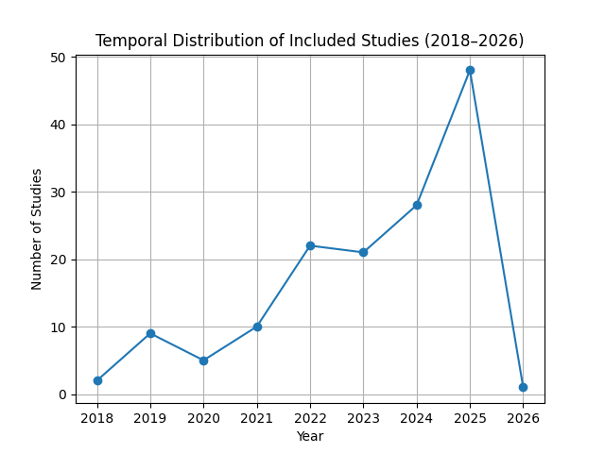
The temporal distribution of the included studies, as shown in Figure 1, reveals a clear and consistent increase in research activity over time. While early contributions between 2018 and 2020 were limited, a notable growth is observed from 2021 onwards, with a sharp rise in publications in subsequent years and a peak in 2025. This pattern indicates a rapidly expanding research focus in this area, likely driven by advancements in wearable technologies, increased availability of sensor data, and growing interest in AI-enabled health systems. This progression is reflected in early representative works[42, 44, 115]and more recent contributions highlighting[7, 109, 117] the evolution of research in this domain.
Figure 1 Temporal Distribution of included studies from year 2018 to 2026
In terms of publication type, most studies were published in journal venues, followed by conference proceedings. This distribution suggests a dual characteristic of the field: on one hand, the presence of a substantial number of journal publications reflects the maturation and consolidation of research, while on the other hand, the continued prominence of conference outputs highlights the dynamic and evolving nature of technological innovation in this domain.
Overall, these findings indicate a rapidly growing and actively evolving research landscape, with increasing contributions over time and strong representation across both established and emerging publication venues.
  - Application Domains and Sub-Domains
The included studies span a diverse range of healthcare application domains, reflecting the broad use of sensing technologies and artificial intelligence in health monitoring, diagnosis, and intervention. As illustrated in Figure 2, a large proportion of studies are concentrated in a limited set of domains, particularly cardiovascular health, activity and behaviour monitoring, and general healthcare systems.
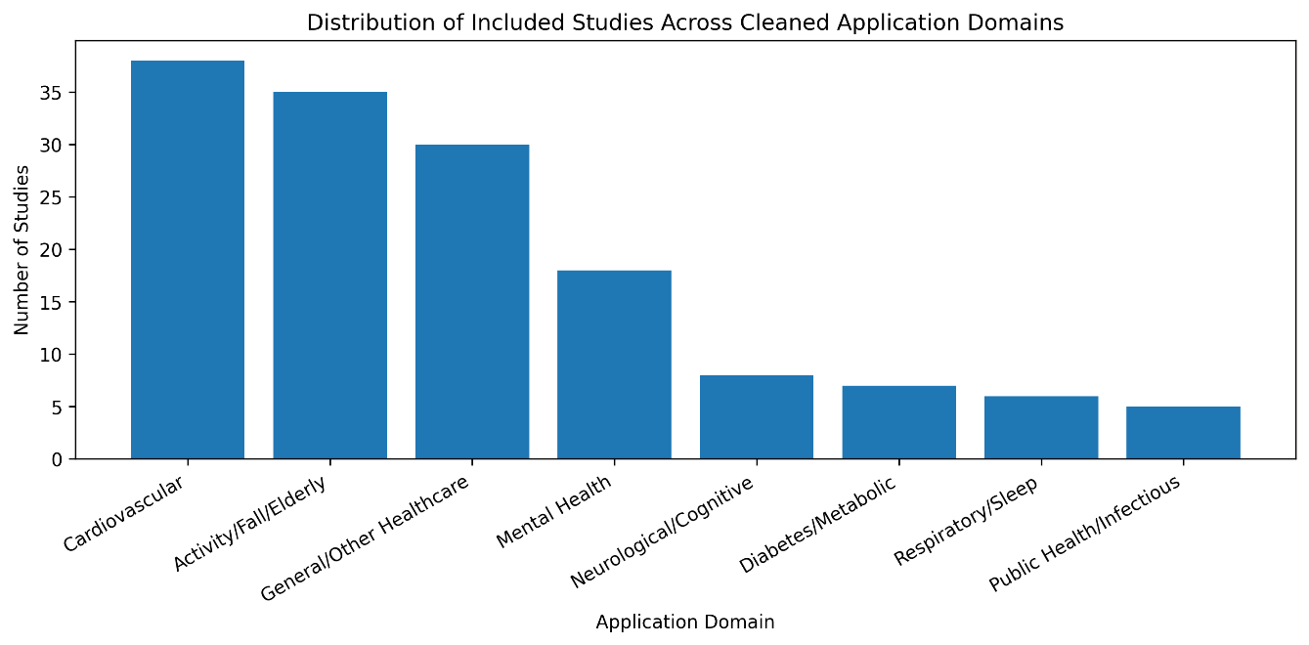
Cardiovascular applications represent one of the most prominent domains, with multiple studies focusing on electrocardiogram (ECG)-based monitoring, arrhythmia detection, and heart rate analysis[44]. This concentration highlights the importance of continuous physiological monitoring for early detection of critical conditions. In parallel, a significant number of studies focus on activity-related applications, including human activity recognition, fall detection, and elderly care[34, 84]. These applications are commonly supported by wearable and motion-based sensing systems and are frequently applied in contexts such as rehabilitation and assisted living.
Figure 2 Distribution of included studies across cleaned application domains.
A notable portion of studies is categorized under general healthcare systems, including remote patient monitoring and integrated smart health platforms[33, 44]. These systems typically combine multiple sensing modalities and aim to provide scalable, real-time monitoring solutions. However, the breadth of this category also reflects a lack of domain specificity, as many studies address generalized monitoring rather than targeted clinical or behavioural outcomes.
In contrast, domains such as mental health, neurological and cognitive disorders, and chronic disease management (e.g., diabetes and metabolic conditions) are comparatively less represented[32, 33]. This indicates that, while physiological monitoring applications are relatively well established, areas requiring behavioural, cognitive, or long-term lifestyle analysis remain less explored.
Further detail is provided in Figure 3, which presents the distribution of specific sub-domains across the included studies. ECG-based cardiac monitoring and arrhythmia detection emerge as the most frequently addressed sub-domains[44], reinforcing the dominance of cardiovascular research. Other commonly studied sub-domains include fall detection, elderly care, and activity recognition[34, 84]. Emerging areas such as mental health monitoring, stress detection, sleep analysis, and neurological disorder identification are also observed, but with lower representation.[32]

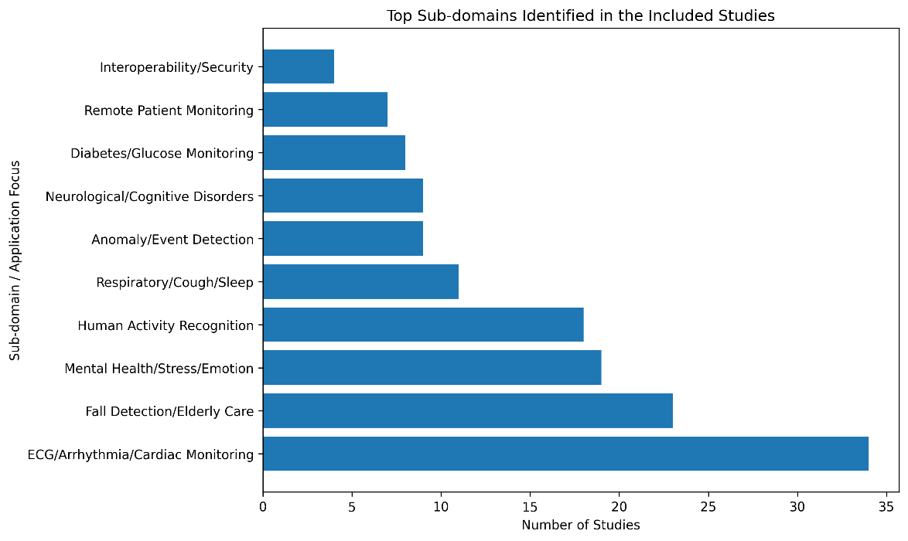
Figure 3 Frequency of major sub-domains and application focuses identified in the included studies
Overall, the distribution across domains and sub-domains suggests that current research is concentrated around a small number of well-established application areas, while a broader set of emerging domains remains fragmented and Overall, the distribution across domains and sub-domains suggests that current research is concentrated around a small number of well-established application areas, while a broader set of emerging domains remains fragmented and underexplored. This highlights the need for more balanced research efforts and greater integration across multiple health domains.
living.
  - Lifestyle behaviors studied
The analysis of the included studies shows that lifestyle behaviours investigated in the literature are predominantly centered around measurable physiological signals and activity-related patterns, with comparatively limited attention given to broader lifestyle habits. The identified behaviours are derived directly from study objectives and sub-domain descriptions within the coding framework. A substantial proportion of studies focus on physical activity and mobility-related behaviours, including human activity recognition, gait analysis, fall detection, posture monitoring, and daily activity tracking.[34, 39, 41, 47, 51, 61, 65, 84] These behaviours are widely applied in contexts such as elderly care, rehabilitation, and ambient assisted living, reflecting the strong reliance on wearable and motion-based sensing technologies[39, 42, 45, 46, 84]. Similarly, physiological monitoring represents a dominant category, particularly in cardiovascular applications, where behaviours are inferred through signals such as heart rate, electrocardiogram (ECG), and blood pressure. This indicates a clear emphasis on biomedical signal-driven behaviour representation, where lifestyle is interpreted through physiological proxies.

In addition to physical and physiological behaviours, the literature includes a growing body of work on mental and emotional states, such as stress detection, emotion recognition, depression assessment, loneliness detection, and broader mental wellbeing monitoring.[28, 32, 49, 70, 75, 88, 89, 113] These behaviours are typically inferred through a combination of physiological signals and behavioral indicators, highlighting an emerging interest in integrating psychological dimensions into health monitoring systems. Sleep-related behaviours, including sleep stage classification and sleep apnea detection, are also represented, reinforcing the importance of sleep as a key component of overall health.[61, 65, 91, 111, 120]
Other categories include respiratory behaviours, such as breathing patterns and cough detection, and behaviours associated with chronic disease management, particularly in diabetes and metabolic conditions. However, these areas are less extensively explored compared to activity and cardiovascular monitoring. Similarly, cognitive and neurological behaviours, including dementia monitoring and seizure detection, are present but remain relatively limited in scope.

Notably, traditional lifestyle behaviours such as diet, nutrition, smoking, and alcohol consumption are minimally represented or absent.Diet-related behaviour appears only in a limited number of studies, such as diabetes lifestyle management and food intake monitoring[37] ,while smoking and alcohol consumption are not meaningfully represented in the coded studies. This absence suggests a significant gap in the literature, as these factors play a critical role in long-term health outcomes but are more difficult to capture through passive sensing.
These findings indicate a clear imbalance in the types of lifestyle behaviours studied, with a strong concentration on behaviours that can be passively sensed and quantified through wearable and physiological data streams. In contrast, complex, context-dependent lifestyle habits that require self-reporting, longitudinal tracking, or multimodal integration remain underexplored, highlighting an important direction for future research.

  - Sensing Technologies and Data Types
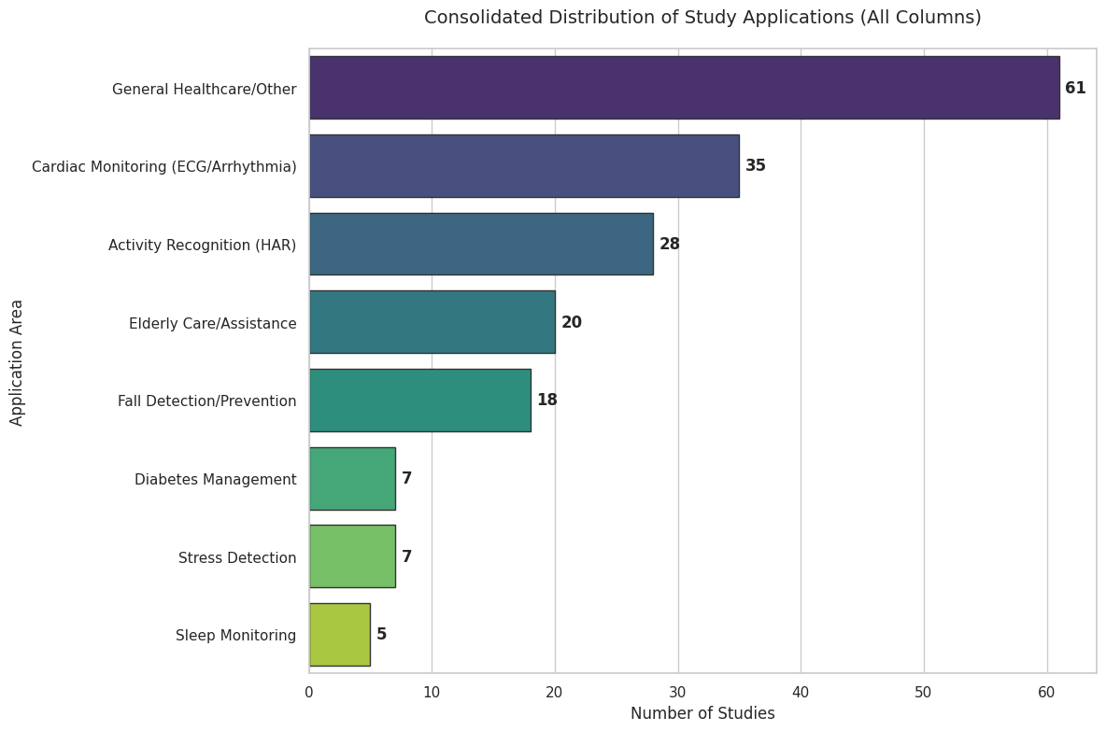
The included studies employ a range of sensing technologies to capture lifestyle-related data; however, as illustrated in Figure 4, there is a clear concentration toward wearable-based sensing systems. Wearable devices account for approximately 48% of the included studies, making them the dominant sensing modality. Several studies rely extensively on wearable sensors such as ECG monitors, smart bands, fitness trackers, and physiological sensing devices for continuous monitoring[35, 39, 44, 69]. In comparison, smartphone-based sensing is used in around 18% of studies, primarily through embedded accelerometers and mobility tracking approaches[34, 41], while ambient and IoT-based sensing approaches account for approximately 16%, indicating significantly lower adoption.
Figure 4 Distribution of sensing technologies used across included studies, highlighting the dominance of wearable-based sensing and comparatively lower use of contextual sensing approaches

This distribution highlights a strong reliance on personal, device-centric sensing, where data is primarily collected through wearable technologies directly attached to the user. In contrast, environmental and context-aware sensing systems remain underrepresented, suggesting limited exploration of broader contextual data that could enhance behavior understanding. Studies incorporating environmental sensing, such as indoor air-quality monitoring and ambient-assisted monitoring systems, remain comparatively limited within the reviewed literature.[36, 46]

A subset of studies adopts multimodal sensing approaches, combining multiple data sources such as wearable, smartphone, and environmental sensors. These approaches account for approximately 18% of the literature, indicating that while integration is emerging, it is not yet a dominant design paradigm. Examples include systems integrating wearable biosensors with smartphone sensing and ambient IoT infrastructures to support comprehensive health monitoring[3, 36, 47]. This limited adoption of multimodal systems reinforces the fragmented nature of current sensing frameworks.

In terms of data types, the reviewed studies capture both physiological and behavioral data, often in combination. Physiological signals, such as heart rate and electrocardiogram (ECG), are widely used, particularly in clinically oriented applications, while behavioral data includes activity patterns, sleep behavior, and mobility indicators. A significant proportion of studies integrate both data types, reflecting a shift toward more holistic sensing approaches. However, consistent with the behavioral trends observed in Section 3.3, the data captured remains largely restricted to signals that can be passively sensed and quantified.

User involvement in data collection further reinforces this pattern. The majority of studies rely on passive sensing, where data is continuously captured without requiring explicit user input. In contrast, active data collection methods, such as self-reported inputs, are less frequently used and typically serve as supplementary components. Hybrid approaches are present but remain limited.

These findings indicate a strong bias toward passive, wearable-driven sensing strategies, which support scalability and real-time monitoring but limit the ability to capture complex, context-dependent lifestyle behaviors. This imbalance, combined with the relatively low adoption of multimodal sensing, suggests a need for more integrated and context-aware sensing frameworks, particularly for comprehensive and long-term health monitoring systems.

  - Data Processing and AI Techniques
The analysis of the included studies reveals a clear dominance of deep learning approaches in the development of health monitoring systems. As shown in Figure 5, deep learning techniques are used in 94 out of 137 studies (approximately 64%), significantly exceeding the use of traditional machine learning methods, which account for 54 studies (36%). A smaller subset of studies (26 instances) employs specialized or hybrid techniques, indicating limited exploration beyond standard model categories. Deep learning-based frameworks are particularly common in wearable and physiological sensing applications, where large-scale time-series data is continuously generated.[44, 47, 69]
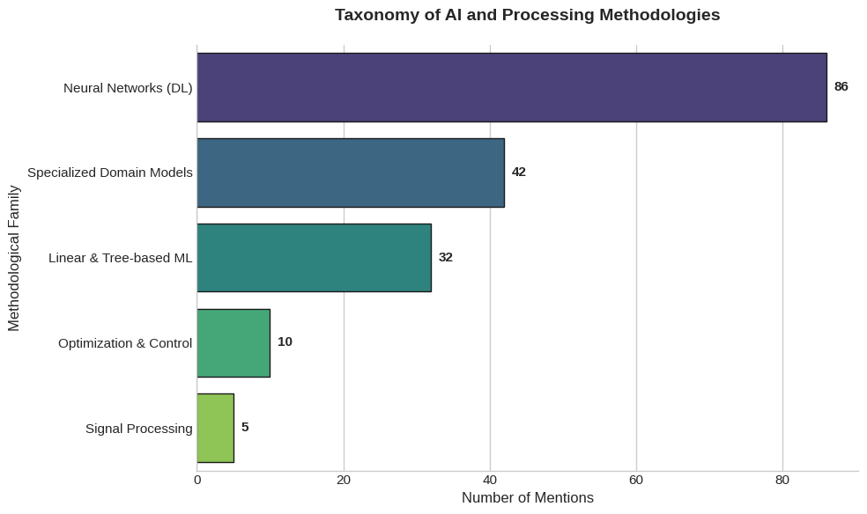
Figure 5 Distribution of AI techniques used across included studies, showing a strong prevalence of deep learning approaches compared to traditional machine learning methods
This distribution highlights a strong shift toward data-driven representation learning, where deep learning models are preferred for handling high-dimensional and time-series sensor data. However, despite this shift, the range of models used remains relatively concentrated. As indicated in Table X, the most frequently used algorithms include Convolutional Neural Networks (CNN) and Multilayer Perceptrons (MLP), each appearing in 47 studies, followed by Long Short-Term Memory (LSTM) networks in 32 studies. CNN-based models are commonly used for signal classification and activity recognition, while LSTM and recurrent architectures are frequently applied to temporal prediction and sequential monitoring tasks[17, 50, 52, 115]
Among traditional machine learning methods, Random Forest and Support Vector Machines are the most commonly used. These models are often adopted in studies requiring lightweight classification, interpretable prediction, or comparison against deep learning baselines. Other conventional techniques, including KNN, Decision Trees, Naive Bayes, Logistic Regression, and AdaBoost, are also used, but with lower frequency across the reviewed literature[56, 79, 88, 92]

This concentration around a limited set of algorithms suggests a reliance on well-established and widely adopted models rather than broad methodological experimentation. Although more advanced architectures such as transformers, attention-based models, and XGBoost appear in the reviewed studies, their adoption remains comparatively limited. These approaches are mainly observed in recent works addressing multimodal health data, federated learning, activity recognition, and more complex sequential prediction problems.[20, 62, 72, 130]

These findings indicate that, although deep learning dominates the field, methodological diversity remains constrained, with many studies relying on a relatively small group of established algorithms. Hybrid models, such as CNN-LSTM, CNN-GRU, attention-enhanced recurrent models, and ensemble-based pipelines, show attempts to improve performance, but these remain less common than standard CNN, MLP, LSTM, Random Forest, and SVM approaches

Furthermore, the predominance of deep learning approaches aligns with the sensing trends observed in Section 3.4, where wearable and continuous sensing systems generate large volumes of time-series data. However, this heavy reliance on computationally intensive models raises questions regarding deployment feasibility, particularly in resource-constrained environments such as edge devices. This limitation becomes more evident when considering the system architectures discussed in Section 3.6, where real-time and on-device processing are critical requirements.[32, 49, 94, 107]

Overall, these findings suggest that while deep learning has become the dominant paradigm in health-related sensing applications, there is a need for greater methodological diversity and stronger alignment between model complexity and deployment constraints, particularly in the context of real-time and privacy-preserving systems.
  - System Architecture
The system architectures adopted across the included studies reflect a shift toward distributed, privacy-aware, and real-time health analytics. However, as illustrated in Figure 7, the integration of key architectural components, namely edge computing, cloud systems, and federated learning (FL), remains limited across the literature.
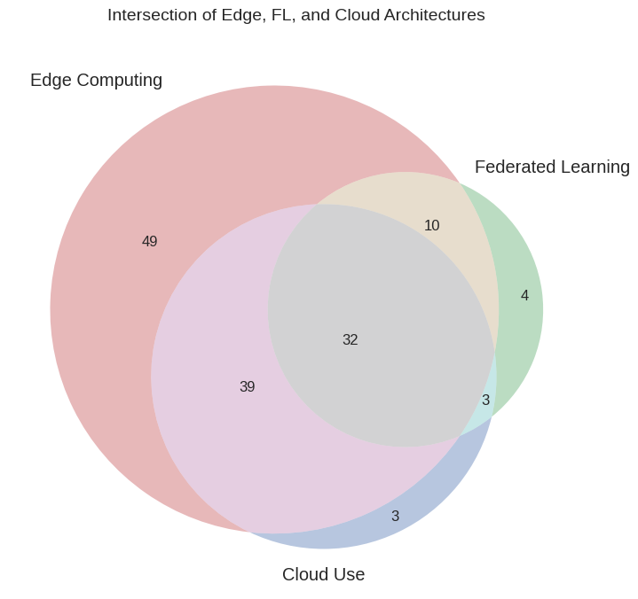
Figure 6 Venn Diagram Showing Usage of Edge computing, Federated Learning and Cloud User across included studies

Edge computing emerges as a widely adopted architectural component, primarily used to enable real-time or near real-time inference on devices such as smartphones, wearables, and local gateways. This trend aligns with the sensing patterns observed in Section 3.4, where device-centric data collection dominates, and supports the need for low-latency processing and reduced data transmission. Edge-based systems commonly handle tasks such as preprocessing, feature extraction, and lightweight inference, enabling immediate feedback and improved responsiveness.[5, 36, 47, 49]

Cloud-based systems are also frequently employed, particularly for computationally intensive operations such as model training, large-scale data storage, and centralized analytics. Many studies adopt a hybrid architecture, where data collected at the edge is partially processed locally and then transmitted to the cloud for further analysis. This reflects a fundamental trade-off between scalability and computational power on one hand, and privacy and latency on the other.[56, 72, 119]

Federated learning is increasingly adopted as a mechanism for privacy-preserving distributed model training. These systems enable collaborative learning across devices without requiring the transfer of raw health data, thereby addressing privacy concerns and regulatory requirements. Applications span cardiovascular monitoring, chronic disease management, mental health assessment, elderly care, and multimodal healthcare analytics. Despite this growing interest, fully integrated architectures combining federated learning, edge intelligence, and cloud infrastructures remain relatively uncommon.

As shown in Figure 6, a key observation is the limited overlap between edge computing, cloud systems, and federated learning. While many studies adopt one or two of these components, only a small proportion integrates all three within a unified framework. This indicates that current research largely explores these architectural paradigms in isolation rather than as part of a cohesive system design.

In terms of deployment, model training is most commonly performed within centralized cloud or institutional infrastructures due to the computational demands of deep learning models and the requirement for aggregated datasets. In contrast, model inference is more frequently executed at the edge or directly on-device to support real-time decision-making and continuous monitoring. Fully decentralized systems, in which both training and inference occur locally on-device, remain comparatively rare because of limitations in computational power, memory availability, and battery efficiency on wearable and embedded platforms.[32, 107]

These findings highlight a critical gap in the literature, where the lack of integration between edge computing, federated learning, and cloud-based systems limits the development of scalable, privacy-preserving, and real-time health monitoring solutions. This gap becomes particularly significant when considered alongside the sensing trends in Section 3.4 and the AI trends in Section 3.5, where increasing data volume and model complexity require coordinated architectural support.
  - Adaptivity and Real-Time Systems
The reviewed studies demonstrate varying levels of system intelligence in terms of adaptivity, ranging from static rule-based systems to dynamically adaptive frameworks capable of responding to user context in real time. Based on the coding sheet classifications, systems can be broadly categorized as static or adaptive, depending on their ability to modify outputs, recommendations, or internal behavior in response to incoming data.

Static systems are primarily characterized by predefined rules, fixed thresholds, or non-adaptive models that generate outputs without adjusting to changing user conditions. These systems often rely on offline-trained models or deterministic logic, where identical inputs produce consistent outputs. While such approaches are computationally efficient and simpler to deploy, they lack personalization and may be insufficient for real-world health scenarios where user behavior and physiological states evolve over time.
In contrast, adaptive systems incorporate mechanisms to respond dynamically to real-time or longitudinal data. These systems leverage continuous sensing and context-awareness to update predictions, personalize feedback, or adjust internal model states. Adaptivity is achieved through approaches such as context-aware rule modification, incremental learning, feedback-driven personalization, and, in some cases, reinforcement learning or adaptive machine learning models. Several studies also integrate adaptive intervention strategies, including personalized notifications and behavior change recommendations, aligning with frameworks such as just-in-time adaptive interventions.
With respect to operational behavior, a substantial proportion of studies emphasize real-time or near real-time inference, particularly in applications involving continuous sensing, wearable monitoring, and user interaction. These systems commonly employ edge or on-device computation, where incoming sensor streams are processed in short temporal windows using techniques such as sliding-window analysis, stream processing, and lightweight sequential inference. Such architectures enable immediate outputs, including activity recognition, anomaly detection, physiological assessment, and real-time health alerts[36, 47, 49]. In hybrid deployments, low-latency inference is typically performed locally at the edge, while computationally intensive analytics and model updates are delegated to cloud infrastructures.

However, not all systems operate in real time. A subset of studies relies on batch-oriented processing pipelines, where sensor data is collected over extended periods and analyzed retrospectively. These systems are generally used for long-term trend analysis, population-level evaluation, offline health assessment, or model benchmarking rather than immediate intervention and adaptive feedback.[11, 111, 119]

These findings indicate a clear shift toward adaptive and real-time systems, driven by the need for responsiveness and personalization in health monitoring applications. However, when considered alongside the architectural patterns in Section 3.6, this shift also exposes a key limitation. While many systems aim to achieve real-time adaptivity, the lack of fully integrated architectures, particularly those combining edge computing and distributed learning, may constrain their scalability and robustness in real-world deployment.
  - Behaviour Change Interventions
The included studies incorporate a range of behaviour change intervention mechanisms aimed at influencing lifestyle behaviours and supporting improved health outcomes. These interventions are typically embedded within mobile health, wearable, or IoT-based systems and delivered through digital interfaces such as smartphone applications or wearable notifications. Across the literature, the primary objective is to translate sensed data and AI-driven insights into actionable and personalized guidance for usersrba[37, 90]

A dominant intervention strategy is the use of feedback mechanisms, where users receive information about their behaviour, physiological state, or progress toward predefined goals. This includes visual dashboards, summaries, and real-time feedback that promote awareness of activity levels, sleep patterns, or stress indicators. For example, Rachakonda et al. (2020) implemented stress-management feedback through a mobile application interface, while Abu-Samah et al. (2025) provided stress classification feedback directly through wearable device displays. In many cases, feedback is personalized based on user-specific data and historical patterns, indicating a shift toward more individualized intervention design[5, 37].

Another widely adopted approach involves prompting and notification-based interventions, where reminders or alerts are triggered based on real-time data or contextual conditions. These interventions are often designed to encourage immediate behavioural responses, such as increasing physical activity or improving sleep routines. several studies implemented alert-generation mechanisms for emergency response, caregiver notification, or abnormal behaviour detection[46, 84, 128]. Some studies extend this approach by incorporating context-aware and time-sensitive delivery, aligning with just-in-time adaptive intervention frameworks, where support is provided at moments of highest relevance.[124]

Goal-setting and self-monitoring mechanisms are also commonly implemented, allowing users to define targets and track their progress over time. These features are frequently combined with motivational elements such as progress indicators or achievements to sustain engagement. In addition, a subset of studies integrates educational components that provide users with information about healthy behaviours and associated risks.

More advanced approaches, including adaptive coaching systems, recommendation engines, and behavioural nudging techniques, are explored in a smaller portion of the literature. These systems dynamically adjust intervention strategies based on user responses and contextual changes, aiming to improve engagement and long-term adherence. For instance, Chelliah et al. (2024) described systems capable of adapting predictions according to positive lifestyle changes, while Baroud (2025) proposed AI-agent-driven personalization supported by federated learning.

These findings indicate that behaviour change interventions are increasingly data-driven and personalized, but remain largely centered on relatively simple mechanisms such as feedback and notifications. When considered alongside the adaptivity trends discussed in Section 3.7, this suggests that although systems are capable of real-time data processing, the sophistication of intervention strategies does not always match the underlying sensing and AI capabilities.

Furthermore, as observed in Section 3.4, the reliance on passively sensed data limits the scope of interventions to behaviours that can be automatically captured, reducing the ability to address more complex lifestyle factors. This highlights a gap between data collection, system intelligence, and intervention design, indicating the need for more integrated, context-rich, and behaviorally grounded intervention frameworks that can fully leverage the capabilities of modern sensing and AI systems. [3, 124]
  - Ethical and Clinical Considerations
The reviewed studies highlight several important ethical and clinical considerations, particularly in relation to privacy, data security, and clinical validation. Given that most systems rely on continuous sensing of sensitive physiological and behavioral data, these factors play a critical role in determining the feasibility and trustworthiness of proposed solutions.

Privacy emerges as a central concern across the literature. Many studies acknowledge the risks associated with collecting and processing personal health data, especially in systems based on wearable devices, smartphones, and ambient sensors. Approaches such as data minimization, anonymization, and local processing are commonly adopted to reduce exposure of raw data. For example, Abu-Samah et al. (2025) reported the use of anonymized datasets, while Birari et al. (2023), Akhmetov et al. (2025)[2], and Baroud (2025)[37] emphasized privacy-preserving mechanisms through federated learning and distributed architectures. As discussed in Section 3.6, architectures incorporating edge computing and federated learning are often motivated by the need to preserve data locality and limit centralized data sharing[47, 69]. However, despite this emphasis, the depth of privacy-related reporting varies considerably. While some studies provide explicit details on data handling and compliance considerations, others mention privacy only at a conceptual level without clearly describing implementation strategies
Data security is addressed through mechanisms intended to protect data during collection, transmission, and storage. Common practices include encryption, secure communication protocols, authentication mechanisms, and access control strategies. These are particularly important in systems that involve cloud or distributed components, where data moves across multiple layers of infrastructure. Studies such as Fallahhusein et al. (2025) [46]specifically referenced compliance with healthcare privacy regulations including HIPAA and GDPR, while Paramasivam et al. (2024)[84] highlighted ethical approval procedures and secure handling of participant data. However, similar to privacy, the level of detail in security implementation is inconsistent. Some studies offer comprehensive descriptions, while others provide only high-level references without technical clarity, making it difficult to assess the robustness of the proposed systems.

From a clinical perspective, the extent of validation varies significantly across the reviewed studies. A subset of work includes real-world or experimental evaluations involving participants, reporting outcomes related to usability, engagement, or health-related improvements. These studies typically involve pilot deployments, controlled experiments, or longitudinal observations. In contrast, a large portion of the literature focuses primarily on technical performance, such as model accuracy, without demonstrating clinical effectiveness or real-world applicability. Moreover, aspects such as integration with healthcare workflows, involvement of medical professionals, and adherence to clinical standards are not consistently addressed.

These findings indicate a gap between technical development and real-world readiness. While privacy and security are widely acknowledged, their implementation is uneven and often underreported. At the same time, limited clinical validation restricts confidence in the practical impact of these systems. When considered alongside the architectural and AI trends discussed in Sections 3.5 and 3.6, this suggests that advances in sensing and modeling are not yet fully matched by progress in deployment, validation, and ethical assurance.
  - Evaluation Metrics
The included studies employ a range of performance evaluation metrics to assess the effectiveness of their proposed models and systems. The choice of metrics is generally aligned with the underlying task, such as classification, regression, or anomaly detection. Across literature, evaluation is predominantly centred on model-level performance, with comparatively limited attention given to system-level and user-centric outcomes.

For classification tasks, which are common in applications such as activity recognition and health state detection, widely used metrics include accuracy, precision, recall, and F1-score. These metrics are often reported together to provide a more balanced view of performance, particularly in scenarios involving imbalanced datasets. For example, Mohamed Abdel-Basset et al.[33] and Birari et al.[5] evaluated classification performance using accuracy, precision, recall, and F1-score measures, while Angelucci et al. [36] and Xiao et al. [124] additionally incorporated confusion matrices and ROC-based evaluation approaches. Additional measures such as AUC-ROC and confusion matrices are also used in some studies to further characterize model behavior.
In regression-based applications, including the prediction of physiological signals or health indicators, metrics such as mean absolute error (MAE), mean squared error (MSE), and root mean squared error (RMSE) are commonly reported. Studies including Akhmetov et al. [ ] and Chelliah et al. [ ] employed error-based metrics to evaluate predictive performance and forecasting accuracy. These measures provide insight into prediction accuracy but are primarily focused on numerical deviation rather than real-world impact.

While these standard metrics are widely used, they largely reflect technical model performance. A smaller subset of studies extends evaluation to system-level considerations, including latency, computational efficiency, and resource utilization, particularly in architectures involving edge computing or real-time processing. For instance, Bochicchio and Zeleke [ ] evaluated processing efficiency within edge-enabled IoT architectures, while Gad and Fadlullah [ ] examined communication and infrastructure-related performance considerations in distributed healthcare systems. Similarly, only a limited number of studies report user-centric metrics, such as usability, engagement, or adherence, which are critical for long-term adoption in real-world settings (Paramasivam et al. [ ]; Fallahhusein et al. [ ]).

These findings indicate a strong emphasis on algorithmic performance, with comparatively limited evaluation of real-world effectiveness. When considered alongside the observations in Section 3.9, where clinical validation is inconsistent, this suggests that many systems are evaluated primarily in controlled or experimental settings without sufficient evidence of practical impact. Furthermore, as discussed in Section 3.5, the dominance of deep learning models is not consistently matched with evaluation frameworks that assess deployment feasibility, interpretability, or user outcomes (Birari et al. [ ]; Baroud [ ]).

Overall, the variability and limited scope of evaluation approaches highlight a key gap in the literature. There is a need for more holistic and standardized evaluation frameworks that integrate technical performance with system-level efficiency, user experience, and clinical relevance, particularly for systems intended for continuous health monitoring and behavioral intervention.
- Discussion
The findings of this systematic review provide a comprehensive view of the current state of research at the intersection of wearable sensing, AI-driven health analytics, and privacy-aware system design. While the field has experienced rapid growth, as demonstrated in Section 3.1, the analysis reveals both significant technological advancements and critical limitations that affect real-world deployment and impact.

A key observation is the strong convergence toward sensor-driven and AI-enabled health monitoring systems. As discussed in Sections 3.4 and 3.5, the majority of studies rely on wearable and mobile sensing technologies combined with deep learning models to infer lifestyle behaviours and detect health risks. At the architectural level, there is a clear transition toward distributed and hybrid systems, where inference is increasingly performed closer to the user. This is reflected in the widespread adoption of edge-based processing and the growing interest in federated learning, as highlighted in Section 3.6. Together, these trends indicate a shift away from centralized data processing toward more responsive, privacy-aware, and context-sensitive systems.

Despite these advancements, the literature remains fragmented across application domains and system designs. As shown in Section 3.2, studies are distributed across a wide range of domains, including physical activity monitoring, mental health, chronic disease management, and general wellness, often with limited overlap. This fragmentation is further reinforced by variability in sensing modalities, data types, and modeling approaches, as discussed in Sections 3.3 and 3.4. The absence of standardized methodologies and interoperable frameworks makes it difficult to compare results, generalize findings, or develop unified systems capable of addressing multiple health behaviours.

Another major limitation is the lack of end-to-end integration across the system pipeline. While individual components such as sensing, AI modeling, and system architecture are well explored, relatively few studies present fully integrated and deployable solutions. As highlighted in Section 3.6, the combined use of edge computing, federated learning, and cloud systems remains limited, with most studies adopting these components in isolation. This lack of integration extends to intervention design, where, as discussed in Section 3.8, behaviour change strategies are often not tightly coupled with real-time sensing and adaptive intelligence. As a result, the potential of these systems to deliver continuous, personalized, and context-aware interventions is not fully realized.

The review also identifies several methodological and evaluation limitations within the existing literature. As discussed in Section 3.10, evaluation is predominantly focused on model-level performance using standard machine learning metrics, with limited attention to system-level efficiency, user experience, or long-term effectiveness. In addition, the findings from Section 3.9 indicate that clinical validation and real-world deployment remain inconsistent, with many studies lacking rigorous evaluation in practical settings. These limitations reduce confidence in the scalability and applicability of proposed systems.

Ethical and security considerations further highlight challenges in transitioning from research to real-world use. While privacy and data protection are frequently acknowledged, as discussed in Section 3.9, their implementation and reporting are uneven. This inconsistency, combined with the reliance on sensitive and continuously collected health data, raises concerns about trust, transparency, and regulatory compliance.

Taken together, these findings suggest that the field is at a critical transition point. Although significant progress has been made in sensing, modeling, and system design, there is a clear need for more integrated, standardized, and clinically validated approaches. Future research should focus on developing end-to-end systems that combine multimodal sensing, diverse AI techniques, and privacy-preserving architectures with robust evaluation frameworks and meaningful intervention strategies.
- Research Gaps and Future Directions
The analysis of the included studies reveals several recurring research gaps that have been explicitly identified within the literature. These gaps reflect limitations in current approaches and highlight key directions for advancing intelligent, sensor-driven health systems. A major gap concerns the limited integration of system components into end-to-end frameworks. Many studies focus on isolated elements such as sensing, data processing, or model development without combining these components into cohesive, deployable systems. As observed in Section 3.6, the lack of integration across sensing, AI, and system architecture restricts the development of scalable and real-time health monitoring solutions. Future research should prioritize the design of holistic architectures that unify sensing, preprocessing, inference, and intervention within a single pipeline.

Another widely reported limitation is the lack of large-scale, diverse, and longitudinal datasets. Several studies rely on small or homogeneous datasets collected in controlled environments, limiting the generalizability of models across populations and real-world contexts. This gap, also reflected in the evaluation limitations discussed in Section 3.10, highlights the need for standardized data collection protocols and open datasets that support robust and externally valid model development.

The underutilization of federated learning and edge intelligence represents another important gap. Although these approaches are recognized for enabling privacy-preserving and real-time analytics, their practical deployment remains limited. As shown in Section 3.6, the integration of edge computing, federated learning, and cloud systems is still incomplete. Future work should focus on developing efficient and scalable distributed learning frameworks, addressing challenges such as communication overhead, model convergence, and resource constraints on edge devices.

Several studies also highlight limitations in adaptive and personalized intervention mechanisms. While behaviour change interventions are commonly included, they are often static or only partially adaptive, as discussed in Section 3.8. This indicates a gap between system intelligence and intervention design. Future research should explore context-aware and just-in-time adaptive intervention frameworks, where real-time sensing and AI-driven decision-making are tightly coupled to deliver timely and personalized support.

A critical gap relates to insufficient clinical validation and real-world evaluation. Many studies emphasize technical performance metrics without demonstrating effectiveness in real-world or clinical environments. As highlighted in Section 3.9, this limits confidence in the practical applicability of proposed systems. Future work should incorporate rigorous clinical trials, longitudinal studies, and real-world deployments to evaluate usability, adherence, and health outcomes.

Ethical and security challenges also remain prominent. Although privacy and data protection are frequently acknowledged, their implementation is not consistently detailed or standardized. This gap aligns with the observations in Section 3.9, where reporting of privacy and security mechanisms varies across studies. Future research should focus on developing robust, transparent, and standardized privacy-preserving frameworks, ensuring compliance with regulatory requirements and enhancing user trust.

Another reported limitation is the lack of model interpretability and transparency, particularly in deep learning-based systems. As discussed in Section 3.5, the dominance of complex models such as neural networks raises concerns regarding explainability and trust. Future work should investigate explainable AI techniques that make model decisions more interpretable for both users and healthcare professionals.

Finally, the literature highlights the absence of standardization and benchmarking across studies. The lack of common datasets, evaluation protocols, and reporting standards makes it difficult to compare results or measure progress across the field. Future efforts should aim to establish standardized benchmarks, open evaluation frameworks, and reproducible research practices.

Taken together, these gaps indicate that while technological capabilities have advanced significantly, progress in integration, validation, and standardization remains limited. Addressing these challenges will be essential for transitioning intelligent health systems from experimental research toward scalable, trustworthy, and real-world applications.
- Conclusion
This systematic literature review provides a comprehensive synthesis of research at the intersection of wearable sensing, mobile health technologies, artificial intelligence, and privacy-aware system design. The findings demonstrate a clear shift toward sensor-driven and AI-enabled health monitoring systems, with widespread use of wearable and smartphone-based sensing to capture lifestyle behaviours. At the same time, system architectures are increasingly moving toward distributed and hybrid designs, incorporating edge computing to support real-time processing and enhance privacy.

A key contribution of this review is its structured and multi-dimensional analysis of the literature, based on a detailed coding framework that captures sensing technologies, data types, AI techniques, system architectures, adaptivity, intervention mechanisms, and evaluation strategies. This approach provides a holistic understanding of the field, highlighting both technological progress and limitations in real-world applicability. The review also brings together evidence on emerging paradigms such as federated learning, edge intelligence, and adaptive interventions, while revealing inconsistencies in their adoption and integration.

Despite significant advancements, several critical challenges remain. The literature is fragmented across domains, and many studies focus on isolated components rather than fully integrated, end-to-end systems. In addition, clinical validation and real-world evaluation are often limited, and the implementation of privacy and security mechanisms is not consistently detailed. These issues indicate a gap between technical development and deployable solutions, which must be addressed to enable practical impact.

Future research should prioritize the development of integrated, adaptive, and privacy-preserving health systems that combine real-time sensing, intelligent analytics, and personalized interventions within a unified framework. Greater emphasis is also needed on large-scale and diverse datasets, standardized evaluation protocols, and rigorous clinical validation, along with improved transparency through explainable AI techniques.

Overall, this review highlights that while the field has made substantial progress, it remains at a transitional stage. Advancing toward scalable and trustworthy real-world systems will require not only improvements in individual components, but also stronger integration, standardization, and validation across the entire system pipeline.

Cite: [1–138]

[1] Abdellatif, A.A. et al. 2019. Edge-based compression and classification for smart healthcare systems: Concept implementation and evaluation. (2019).
[2] al., A.A. et 2025. Enhancinghealthcaredataprivacyand interoperabilitywithfederatedlearning. (2025).
[3] al., C. et 2024. DeepHealth: Deep Learning-Powered Smart App for Personalized Health Tracking. (2024).
[4] al., D.G. et 2021. Future Smart Connected Communities to Fight COVID-19 Outbreak. (2021).
[5] al., D.R.B. et 2023. Towards a Holistic Approach to Chronic Disease Management: Integrating Federated Learning and IoT for Personalized Health Care. (2023).
[6] al., E.D.G. et 2023. Adaptive R-Peak Detection on Wearable ECG Sensors for High-Intensity Exercise. (2023).
[7] al., G. et 2026. Real-Time Human Fall Detection Using YOLOv5 on Raspberry Pi An Edge AI Solution for Smart Healthcar. (2026).
[8] al., H. et 2021. A Deep Segmentation Network of Stent Structs Based on IoT for Interventional Cardiovascular Diagnosi. (2021).
[9] al., H. et 2022. RhythmEdge: Enabling Contactless Heart Rate Estimation on the Edge. (2022).
[10] al., H.G. et 2025. Cardio Rescue Network in AI-Driven Wearable System for Real-Time Cardiac Event Prediction and Manage. (2025).
[11] al., I. et 2021. ECG-TCN Wearable Cardiac Arrhythmia Detection with a Temporal Convolutional Network.
[12] al., I. et 2023. Enhancing Healthcare Efficacy Through IoT-Edge Fusion A Novel Approach for Smart Health Monitoring. (2023).
[13] al., J. et 2025. A Self-Calibrated, Wearable Vital Sign Monitoring Device Enabled by Edge Computing. (2025).
[14] al., J. et 2023. Cognitive Health Assessment of Decentralized Smart home Activities using Federated Learning. (2023).
[15] al., J. et 2023. Enhancing Healthcare with Edge AI for Analysis of Cough Detection. (2023).
[16] al., J. et 2023. FedRadar Federated Multi-Task Transfer Learning for Radar-Based Internet of Medical Things. (2023).
[17] al., J. et 2024. Tremor Detection in Parkinson’s Disease from Wearable Data A Comparative Study of Centralized Learn. (2024).
[18] al., J.S. et 2024. Federated clustered multi-domain learning for health monitoring. (2024).
[19] al., J.V.S. et 2025. Wearable Health Monitoring System Using Embedded Sensors and Edge Computing. (2025).
[20] al., K. et 2025. Cross-modal Hybrid Ensemble Deep Learning for Ultra-early Disease Detection. (2025).
[21] al., K. et 2025. Poster Smart ECG Classification with Wearable Sensing and Cloud AI A Mobile Health Approach Using. (2025).
[22] al., K. et 2024. Smart Wearable Embedded Systems for Human Activity Recognition (HAR) Using Edge Computing. (2024).
[23] al., L. et 2024. A UWB-Radar-Based Adaptive Method for In-Home Monitoring of Elderly. (2024).
[24] al., L.B.A. et 2025. Human-Centric Edge Intelligence with Gaussian Splatting for Privacy-Aware Elderly Care. (2025).
[25] al., L.F. et 2021. Bayesian Inference Federated Learning for Heart Rate Prediction. (2021).
[26] al., L.S.H. et 2024. Using a Bodily Weight-Fat Scale for Cuffless Blood Pressure Measurement Based on the Edge Computing. (2024).
[27] al., M.G. et 2024. Edge-AI on Wearable Devices: Myocardial Infarction Detection with Spectrogram and 1D-CNN. (2024).
[28] al., N.F. et 2024. A Smart Federated Learning Approach for Mental Health Detection.
[29] al., P. et 2025. AI-Powered IoT System for Constant Urine Output Monitoring in Critically Ill Patients. (2025).
[30] al., Q. et 2019. Edge-AI in LoRa-based health monitoring Fall detection system with fog computing and LSTM recurrent. (2019).
[31] al., T.B. et 2022. Design of a Realtime Photoplethysmogram Signal Quality Checker for Wearables and Edge Computing. (2022).
[32] all, A. abu-samah et 2025. Deployment of TinyML-Based Stress Classification Using Deployment of TinyMl-based stress classification using Computational Constrained Health Wearable. (2025).
[33] all, M. abdel-basset et 2020. A Novel Intelligent Medical Decision Support A novel intelligent medical decision support Model Based on Soft Computing and IoT. (2020).
[34] Alzubi, A. et al. 2025. G-CTRNN: A Trainable Low-Power Continuous-Time Neural Network for Human Activity Recognition in Healthcare Applications. (2025).
[35] Amiri, D. et al. 2022. SIC-EDGE: Semantic Iterative ECG Compression for Edge-Assisted Wearable Systems. (2022).
[36] Angelucci, A. et al. 2021. A Home Telemedicine System for Continuous Respiratory Monitoring. (2021).
[37] baroud 2025. AI-Powered Multi-Agent System for Type 2 Diabetes Care: IoT, Federated Learning and Mobile Health Integration. (2025).
[38] BENGHERBIA, B. et al. 2022. Real-Time Smart System for ECG Monitoring Using a One-Dimensional Convolutional Neural Network. (2022).
[39] Cay, G. et al. 2025. SmartBoot: Real-Time Monitoring of Patient Activity via Remote Edge Computing Technologies. (2025).
[40] Chellamani, N. et al. 2025. Diabetes: Non-Invasive Blood Glucose Monitoring Using Federated Learning with Biosensor Signals. (2025).
[41] Chen, Y. et al. 2020. FedHealth: A Federated Transfer Learning Framework for Wearable Healthcare. (2020).
[42] Cooney, N.J. et al. 2018. A Wearable Internet of Things Based System With Edge Computing for Real-Time Human Activity Tracking. (2018).
[43] Cruz, D.R. et al. 2024. Fall Risk Classification Using Trunk Movement Patterns from Inertial Measurement Units and Mini-BESTest. (2024).
[44] Disi, M. Al et al. 2018. The Accuracy and Efficacy of Real-time Compressed ECG Signal Reconstruction on a Heterogeneous Multicore Edge-Device. (2018).
[45] Fahim, M. et al. 2025. Edge Intelligence: A Deep Distilled Model for Wearables to Enable Proactive Eldercare. (2025).
[46] FALLAHHUSEIN, M. et al. 2025. INTELLIGENT UBIQUITOUS SPACES FOR ELDERLY ASSISTANCE AND CARE. (2025).
[47] Gad, G. and Fadlullah, Z. 2022. Federated Learning via Augmented Knowledge Distillation for Heterogenous Deep Human Activity Recognition Systems. (2022).
[48] GadGad1 2, * andZubairFadlullah 1 2022. Federated Learning via Augmented Knowledge Distillation for Heterogenous Deep Human Activity Recognition Systems. (2022).
[49] Ganesan, P. et al. 2025. TinyML Based Stress Detection utilizing PPG Signals: A Lightweight Approach for Smart Wearable Devices. (2025).
[50] Gaud, N. et al. 2024. Hybrid Deep Learning-Based Human Activity Recognition (HAR) Using Wearable Sensors An Edge Computing Approach.
[51] Ghosh, S. and Ghosh, S.K. 2023. FEEL: FEderated LEarning Framework for ELderly Healthcare Using Edge-IoMT. (2023).
[52] Ghosh, S. and Mukherjee, A. 2022. STROVE: spatial data infrastructure enabled cloud-fog-edge computing framework for combating COVID-19. (2022).
[53] Gia, T.N. et al. 2019. Energy efficient fog-assisted IoT system for monitoring diabetic patients with cardiovascular disease. (2019).
[54] Greco, L. et al. 2019. An edge-stream computing infrastructure for real-time analysis of wearable sensors data. (2019).
[55] HAAS, P. and DESERNO, T.M. 2023. Technological Assessment of Smart Wearables and 5G-Integrated Edge Computing for Real-Time Health Monitoring.
[56] Hassantabar, S. et al. 2022. MHDeep: Mental Health Disorder Detection System Based on Wearable Sensors and Artificial Neural Netw. (2022).
[57] Hizem, M. et al. 2025. Reliable ECG Anomaly Detection on Edge Devices for Internet of Medical Things Applications. (2025).
[58] Hong, M. et al. 2024. Comprehensive Symptom Prediction in Inpatients With Acute Psychiatric Disorders Using Wearable-Based Deep Learning Models: Development and Validation Study. (2024).
[59] Jain, A. and Bhullar, S. 2025. AI-driven wearable health devices with health-aware control and secure Prognostics: Experimental and Simulation-Based Validation. (2025).
[60] Ji, Y. et al. 2024. Machine Learning-Based Automated Detection of ADHD Using Heart Rate Variability Data. (2024).
[61] Kamath, C.V. et al. 2022. Privacy-Preserving In-Bed Pose and Posture Tracking on Edge. (2022).
[62] Khan, S. et al. 2025. FedTinyMed: Federated learning enabled tiny multi task machine learning model for smart healthcare monitoring for IoMT. (2025).
[63] Krishna, S. et al. 2025. Edge-AI Enabled IoT Framework for Real-Time Stroke Risk Prediction using Multimodal Biosignals. (2025).
[64] Lee, L. and 2021. PPG-Based Smart Wearable Device with Energy-Efficient Computing for Mobile Health-Care Applications. (2021).
[65] Lin, B.-S. et al. 2023. System Based on Artificial Intelligence Edge Computing for Detecting Bedside Falls and Sleep Posture. (2023).
[66] Liu, X. et al. 2025. Interpretable Semi-federated Learning for Multimodal Cardiac Imaging and Risk Stratification. (2025).
[67] Liu, Z. et al. 2025. FPGA-based 1D-CNN accelerator for real-time arrhythmia classification. (2025).
[68] Makhlooghpour, A. and Ahmadi, A. 2023. A Dual Stage Resource Efficient ECG Classifier. (2023).
[69] Mario Bochicchio, S.N.Z. 2023. Privacy-Preserving Federated Learning for In-home Monitoring of Elderly Using Wearable Biometric Sensors. (2023).
[70] Martis, G. and McConville, R. 2025. Federated Mental Wellbeing Assessment Using Smartphone Sensors Under Unreliable Participation. (2025).
[71] Mehta, S. and Kundra, D. 2024. Advanced Cardiac Signal Processing with Federated Learning and IoT for Remote Health Monitoring. (2024).
[72] Msigwa, C. et al. 2024. IoT-driven wearable devices enhancing healthcare: ECG classification with cluster-based GAN and meta-features. (2024).
[73] Muhammad, G. et al. 2019. Computing and processing on the edge: Smart pathology detection for connected healthcare. (2019).
[74] Najafi, T.A. et al. 2024. VersaSens An Extendable Multimodal Platform for Next-Generation Edge-AI Wearables. (2024).
[75] Nandi, A. and Xhafa, F. 2022. A federated learning method for real-time emotion state classification from multi-modal streaming. (2022).
[76] Nawaz, A. et al. 2025. Blockchain-Enabled Privacy-Preserving Second-Order Federated Edge Learning in Personalized Healthcare. (2025).
[77] Ngu, A.H. et al. Personalized Watch-based Fall Detection Using a Collaborative Edge-Cloud Framework.
[78] O, Dr.S.P. et al. 2025. Heartify: A Federated Learning-Based Application for Early Heart Disease Detection. (2025).
[79] Obasi, C. et al. 2025. Framework for Cloud-Centric Internet of Medical Things for Real-Time Disease Diagnosis. (2025).
[80] Ouyang, X. 2023. Design and Deployment of Multi-Modal Federated Learning Systems for Alzheimer’s Disease Monitoring. (2023).
[81] Padmavilochanan, D. et al. 2023. Personalized diabetes monitoring platform leveraging IoMT and AI for non-invasive estimation. (2023).
[82] Pal 2025. An AIoT-based Real-time Remote Health Monitoring device. (2025).
[83] Pankaj et al. 2024. Edge-Based Computation of Super-Resolution Superlet Spectrograms for Real-Time Estimation of Heart Rate. (2024).
[84] Paramasivam, A. et al. 2024. Development of Artificial Intelligence Edge Computing Based Wearable Device for Fall Detection and Prevention of Elderly People. (2024).
[85] Pazienza, A. et al. 2020. Adaptive Critical Care Intervention in the Internet of Medical Things. (2020).
[86] Pazienza, A. and Monte, D. 2022. Introducing the Monitoring Equipment Mask Environment. (2022).
[87] Prabhu, M. and Hanumanthaiah, A. 2022. RescuTrack An Edge Computing-Enabled Vitals Monitoring System for First Responders. (2022).
[88] Qirtas, M.M. et al. 2022. Privacy Preserving Loneliness Detection: A Federated Learning Approach. (2022).
[89] Qirtas, M.M. et al. 2025. Unmasking Nuances Affecting Loneliness: Using Digital Behavioural Markers to Understand Social and Emotional Loneliness in College Students. (2025).
[90] Rachakonda, L. et al. 2020. iLog: An Intelligent Device for Automatic Food Intake Monitoring and Stress Detection in the IoMT. (2020).
[91] Rahman, M.J. et al. 2022. A pilot study towards a smart-health framework to collect and analyze biomarkers with low-cost and flexible wearables. (2022).
[92] Rahman, M.J. and Morshed, B.I. 2021. A Minimalist Method Toward Severity Assessment and Progression Monitoring of Obstructive Sleep Apnea on the Edge. (2021).
[93] Rahman, M.J. and Morshed, B.I. 2024. A Smart Wearable for Real-Time Cardiac Disease Detection Using Beat-by-Beat ECG Signal Analysis. (2024).
[94] Rahman, M.J. and Morshed, B.I. 2025. Resource-Constrained On-Chip AI Classifier for Beat-by-Beat Real-Time Arrhythmia Detection. (2025).
[95] Rahman, S. et al. 2025. Privacy-Preserving Lightweight Federated Learning for Heterogeneous Data in Internet of Medical Things. (2025).
[96] Rashid, N. and al., et 2022. SELF-CARE Selective Fusion with Context-Aware Low-Power Edge Computing for Stress Detection. (2022).
[97] Rathore, K.S. et al. 2023. A Multifunctional Network with Uncertainty Estimation and Attention-Based Knowledge Distillation. (2023).
[98] Regalado, P.H. and Han, T. 2025. MediVerse: A Secure and Scalable IoT-MR Framework for Real-Time Health and Performance Monitoring. (2025).
[99] Sakib, S. et al. 2021. Asynchronous Federated Learning-based ECG Analysis for Arrhythmia Detection. (2021).
[100] Saranya, S. et al. 2025. AI-Driven Anomaly Detection in Graphene-Based Wearable Sensors for Real-Time Remote Patient Monitoring. (2025).
[101] Saraswat, D. and Das, M.L. 2021. Edge-enabled Secure Healthcare System. (2021).
[102] Sayeed, M.A. and Mohanty, S.P. 2019. ESeiz An Edge-Device for Accurate Seizure Detection for Smart Healthcare. (2019).
[103] Scrugli, M.A. et al. 2022. An Adaptive Cognitive Sensor Node for ECG Monitoring in the Internet of Medical Things. (2022).
[104] Shaik, T. et al. 2022. FedStack: Personalized activity monitoring using stacked federated learning. (2022).
[105] Shaikh, M.S. et al. 2025. Federated Edge Intelligence for Privacy-Preserving Pre-eclampsia Prediction in IoT-Based Maternal Care. (2025).
[106] Shaikh, M.S. et al. 2025. The Digital Pulse Reshaping Clinical Accuracy with Sensor Based Smart Diagnostics. (2025).
[107] Shakya, S.R. et al. 2025. Optimized CNN-Based Fall Detection for Elderly Using Wearable Devices on Resource-Constrained Devices. (2025).
[108] Shankar, A. et al. 2024. A Multimodel-Based Screening Framework for C-19 Using Deep Learning-Inspired Data Fusion. (2024).
[109] Simon, J. and Kapileswar, N. 2025. Federated Deep Learning-Driven Cloud-IoT Framework for Real-Time Healthcare Monitoring and Privacy-Preserving. (2025).
[110] Singh, S. et al. 2025. Performance analysis of blockchain-based secured distributed deep federated learning for wearable internet of things. (2025).
[111] Stephen Dewanto Nico Surantha, M.A. 2020. Heart Rate Monitoring with Smart Wearables using Edge Computing. (2020).
[112] Sun, L. and Wu, J. 2023. A Scalable and Transferable Federated Learning System for Classifying Healthcare Sensor Data. (2023).
[113] Tabassum, N. et al. 2023. Depression Detection Through Smartphone Sensing: A Federated Learning Approach. (2023).
[114] Tian, J. et al. 2024. Ultra low-power, wearable, accelerated shallow-learning fall detection for elderly at-risk persons. (2024).
[115] Torti, E. et al. 2019. Deep Recurrent Neural Networks for Edge Monitoring of Personal Risk and Warning Situations. (2019).
[116] Uddin, Md.Z. 2019. A wearable sensor-based activity prediction system to facilitate edge computing in smart healthcare system. (2019).
[117] Vashisht, S. and Rani, S. 2025. FSSL-TCN-Per: A Federated Semi-Supervised Personalized Model for Next-Generation Secure Bio-Medical and Healthcare Solutions. (2025).
[118] Vinitha, S. et al. 2025. Smart Sensor Networks for Breast Cancer Screening and Monitoring. (2025).
[119] Wan, S. et al. 2019. Deep Learning Models for Real-time Human Activity Recognition with Smartphones. (2019).
[120] Wang, A. et al. 2024. A Quantized Parsimonious CNN Model for Sleep Polysomnogram Data Streams. (2024).
[121] Wang, L. et al. 2022. Context-aware emergency detection method for edge computing-based healthcare monitoring system. (2022).
[122] Warrier, L.C. et al. 2023. Privacy-Preserved Stress Detection from Wearables using Federated Learning. (2023).
[123] Wilkie, B. et al. 2024. An LSTM Framework for the Effective Screening of Dementia for Deployment on Edge Devices. (2024).
[124] Xiao, L. et al. 2024. A hybrid deep approach to recognizing student activity and monitoring health physique based on accelerometer data from smartphones. (2024).
[125] Yadav, R. et al. 2024. A novel healthcare framework for ambient assisted living using the internet of medical things (IOMT) and deep neural network. (2024).
[126] Yadav, S.S. et al. 2023. tinyRadar for Fitness: A Contactless Framework for Edge Computing. (2023).
[127] Yang, Y. et al. 2025. 柔性呼吸传感技术的医疗级开发: 医学物理 实现路径与临床肺功能数据验证. (2025).
[128] Yazici, A. et al. 2023. A smart e-health framework for monitoring the health of the elderly and disabled. (2023).
[129] Yu, C. et al. 2022. Efficient Multi-Layer Stochastic Gradient Descent Algorithm for Federated Learning in E-health. (2022).
[130] Zafar, R.O. and Zafar, F. 2025. Real-time activity and fall detection using transformer-based deep learning models for elderly care applications. (2025).
[131] Zhang, D. (Yue) et al. 2021. FedSens: A Federated Learning Approach for Smart Health Sensing with Class Imbalance in Resource Constrained Edge Computing. (2021).
[132] Zhantleuova, A.K. et al. 2025. Optimizing MFCC Parameters for Breathing Phase Detection. (2025).
[133] Zhao, K. et al. 2022. A Binarized CNN-Based Bowel Sound Recognition Algorithm With Time-Domain Histogram Features for Wearable Healthcare Systems. (2022).
[134] ZHAO, S. et al. 2025. Optimized Federated Learning for Multimodal Big Data Fusion in Elderly Chronic Disease Management. (2025).
[135] Zhao and Xiong 2025. Prediction of Elderly Behavior Patterns Based on Big Data in Smart Elderly Care. (2025).
[136] Zheng, Y. et al. 2024. Tiny-PPG: A Lightweight Deep Neural Network for Real-Time Detection of Motion Artifacts in Photoplethysmogram Signals on Edge Devices. (2024).
[137] Zhou, F. et al. 2023. A Semi-Supervised Federated Learning Fault Diagnosis Method Based on Adaptive Class Prototype Points for Data Suffered by High Missing Rate. (2023).
[138] Zhou, X. et al. 2023. Hierarchical Federated Learning With Social Context Clustering-Based Participant Selection for Internet of Medical Things Applications. (2023).

* Place the footnote text for the author (if applicable) here.

